OBSERVATION FOR HANDSON 2
Context Window: It’s about how much tokens does your model remember.

Google API Keys from gemini: from Google AI Studio

Langchain is basically framework where you make an entire pipeline , it’s more like NA10
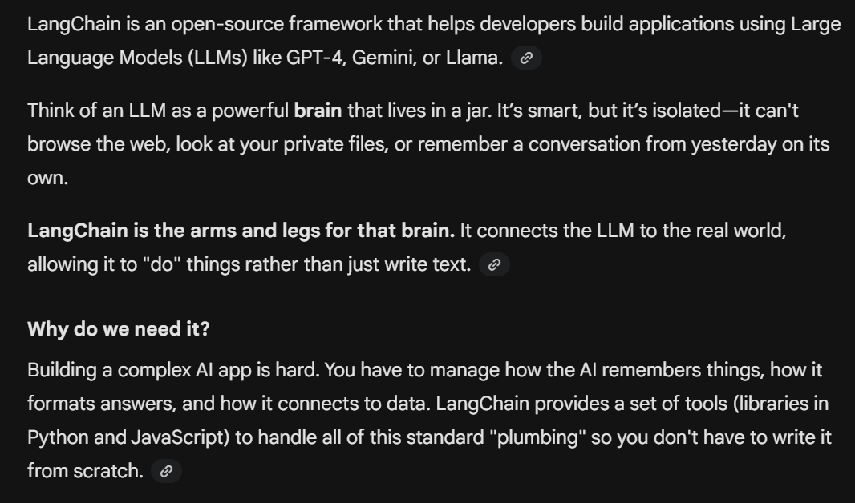
LangChain Expression lang
It helps build pipeline

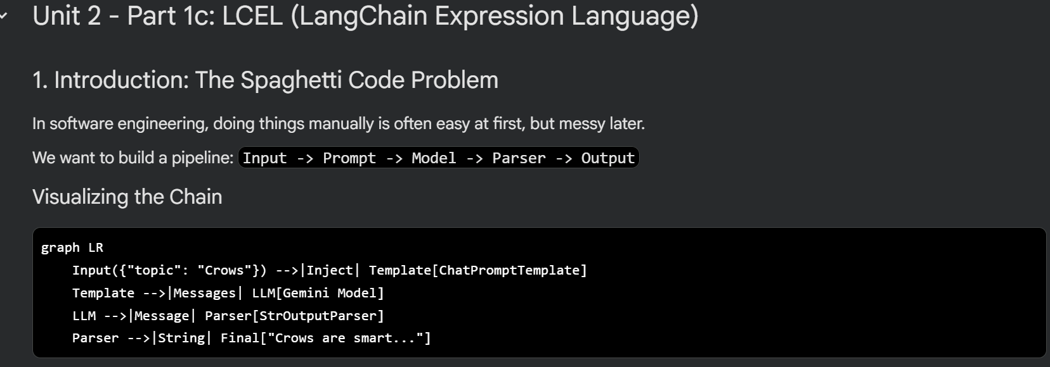

We understood that it’s better to do it in the good LCEL way using the function directly
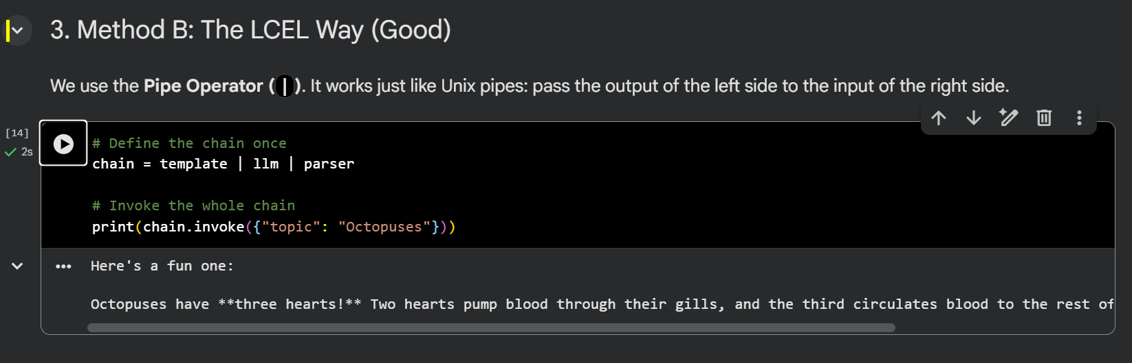

The problem with manual is you manually try to find the invoke
But with LCEM way you just make changes to llm variable as seen below:
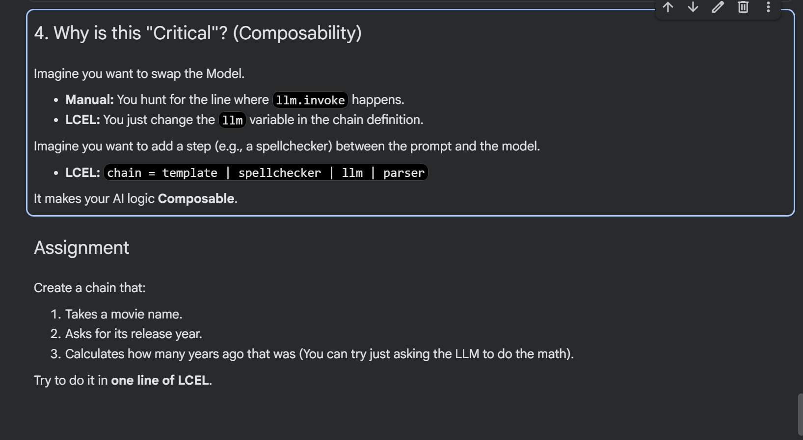

2_Prompt_Engineering.ipynb

We saw what is difference between Lazy prompt and CO-STAR prompt
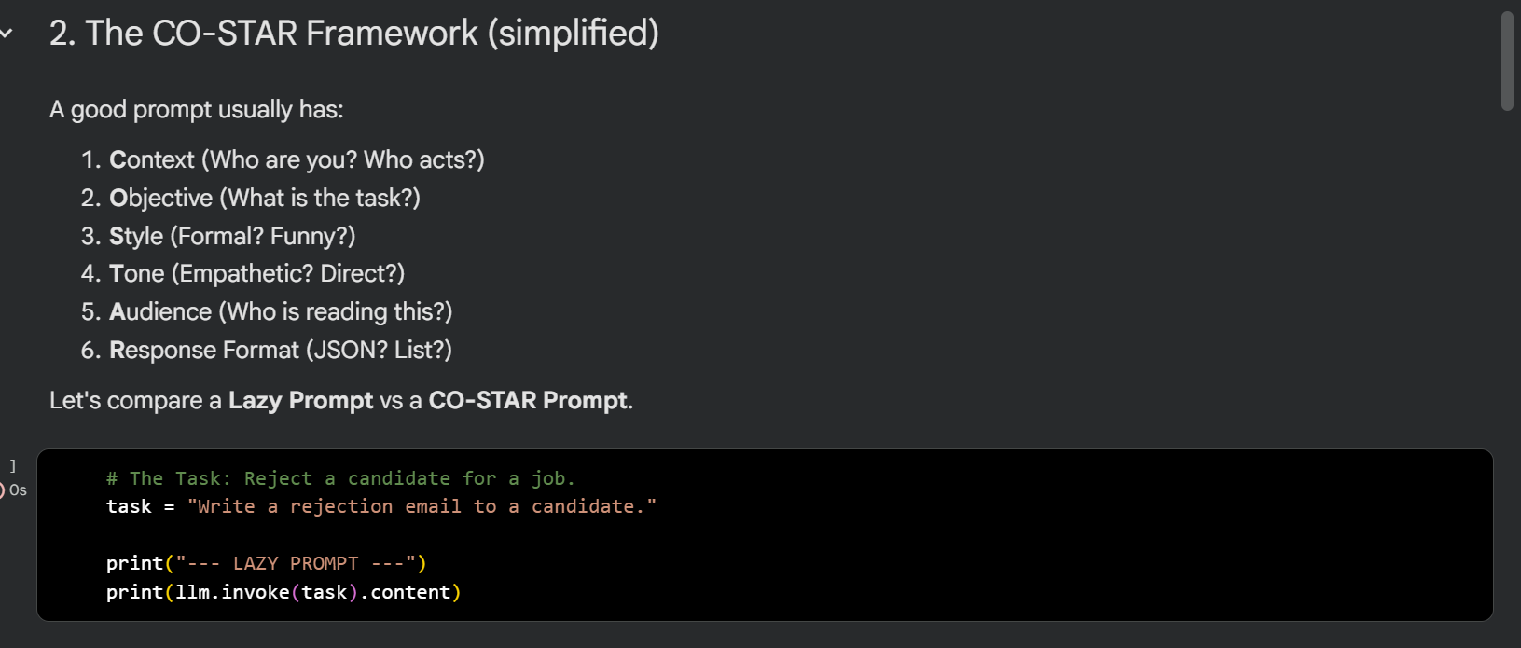
Learning about Hard Prompt and Soft Prompt:
Hard prompt is about how good you hardcore your query to an llm

Whereas soft prompting is about changing the paramters of model to behave in certain way according to a particular bheaviour it can be used in things li,e personalizing my llm

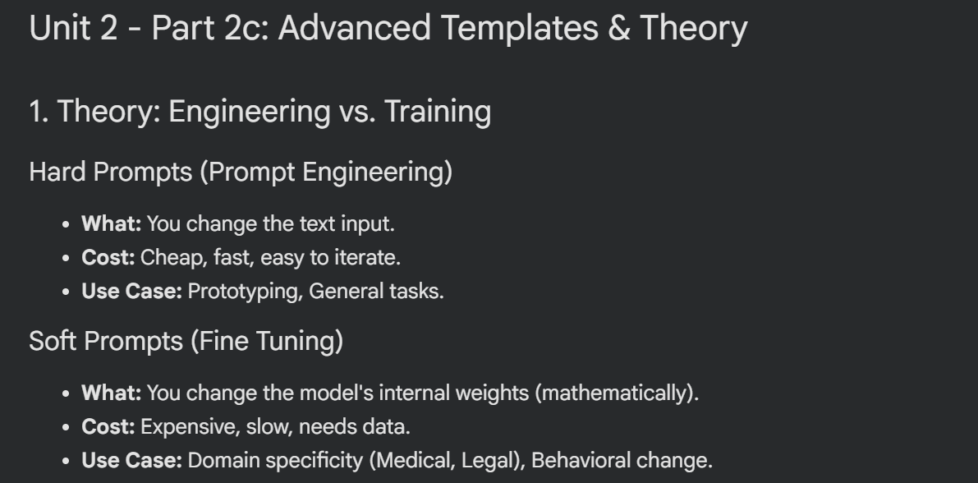
We learnt about few shot learning zero shot learning as part of handson in a partcical way after the theory parts were taught in class.

Chain of thought:
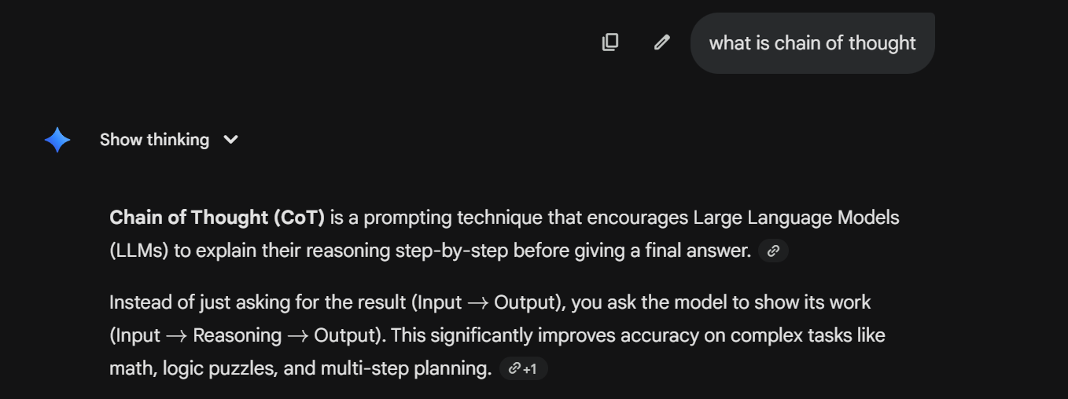division of a simple problem into multiple smaller problems is called chain of thought basically you divide your problem into multiple smaller steps. 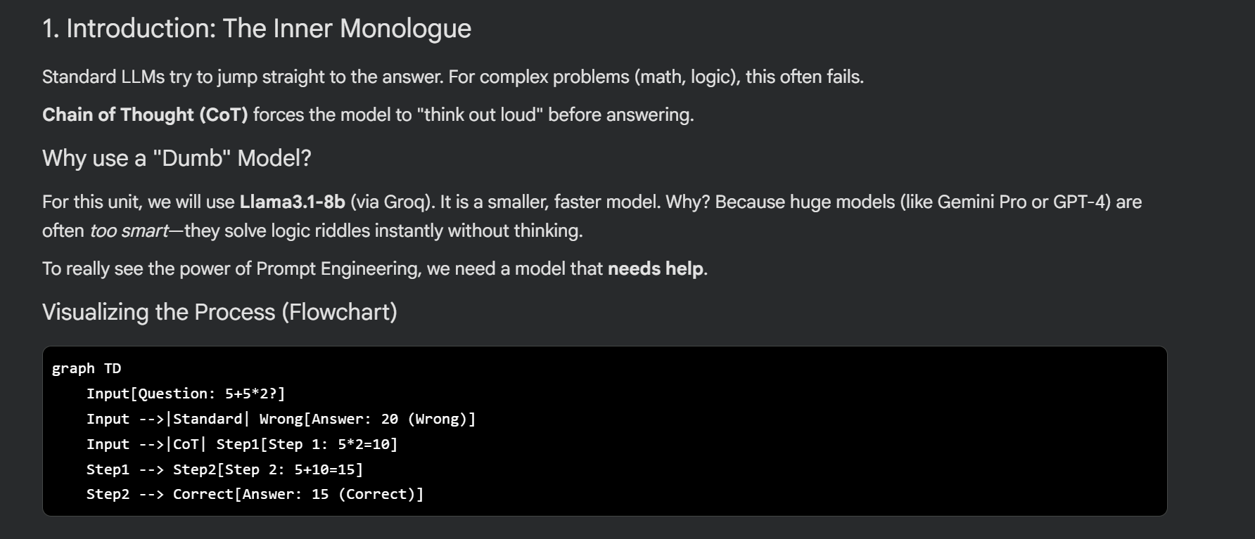

Tree of thoughts:
you can chose between multiple paths and try to find out which one is the best one that is optiomal answer that’s wehre we use tree of thought :
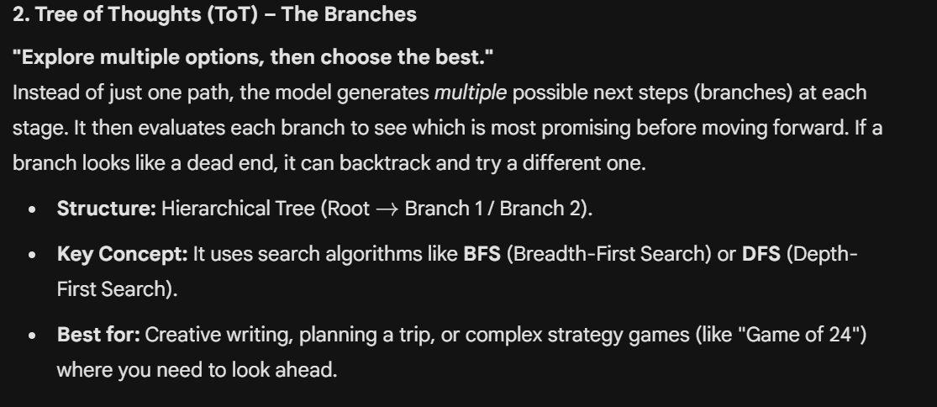
Graph of thoughts:
It’s more about using a graph and nodes to understand for understanding whole path , Dijkstra types or something , and want to map things from required nodes and make sure every single output is related to previous and next output.
Graph of thoguth helps you manage a way of managing that is if you make a mistake you back track over the nodes you have travered to reason between the things an example given to us with the breaking bad thing like if as a director we are trying to map series scenes to past and future.
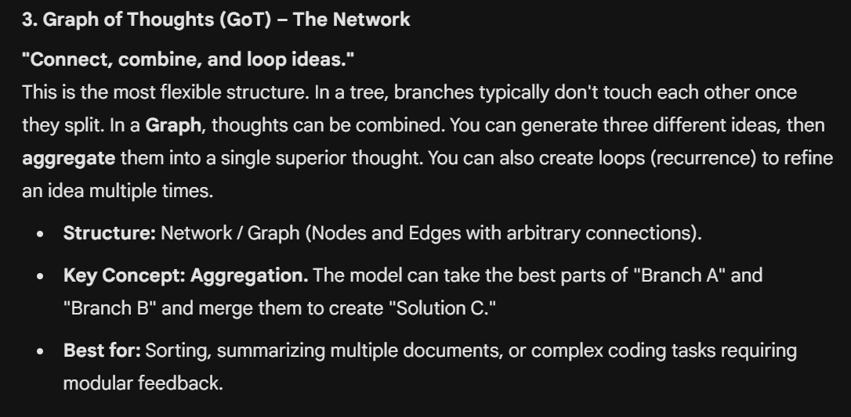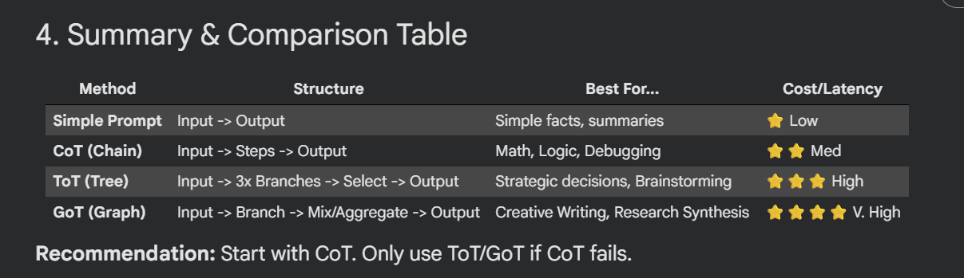

RAG MODELS: 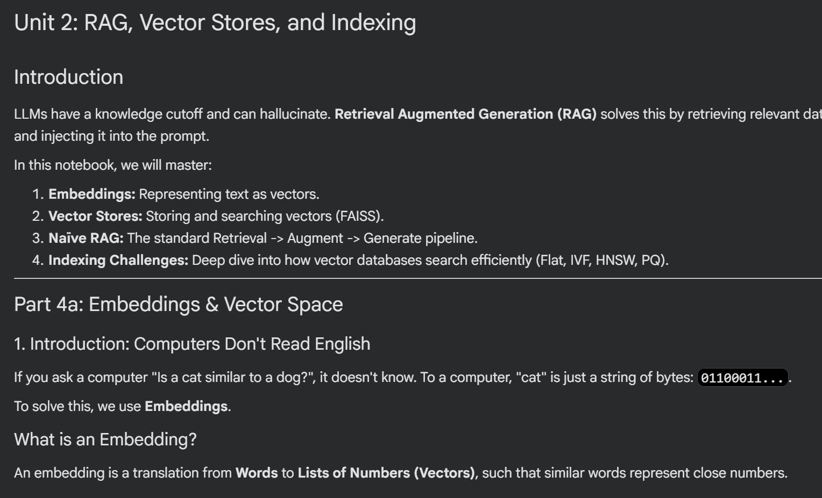
Parametric: information the models have predefined in your models during fine tuning
Non Paramteric : the information you get during the runtime, which are not related to the things that are already there in the model related to paramters.

Vectorization: converting your text into embeddings to store information as a vector that helps your model understand the information and run the models

We sue cosine similarity to matcht the vector embeddings .
VectorDB: It is used to match using cosine similarity and store the vector embeddings.

RAG has the four components:
- Embeddings
- Vector stores
- Naïve RAG
- Indexing challenges
Initially RAG is ingested with data to make the LLM more relevant in the present day world
The better the vectorDB the better is your output because the better i/p you feed to RAG the better o/p it will give you.

Product Quanitzation:
It basically is compressing your existing paramters to be able to run it on models which are having less compute and stuff like portable devices mobile. This it the advantage and comes with disadvantage that as you have decreased or compressed the paramters your accuracy of the model and stuff is affected as well.

